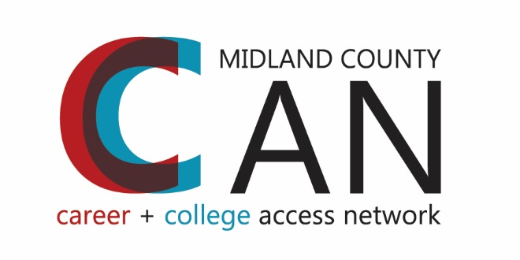
Midland County Career & College Access Network
Common Agenda

Urgency for Change:
Midland County needs strong workforce equipped to compete in a 21st century global economy. In order to build and sustain a vibrant economy and strong community based on a highly educated population, Midland County Career and College Access Network works to ensure everyone in Midland County has the opportunity to access and succeed in postsecondary education.
Background:
When we consider our community demographics and the percent of our population in each education level, we realized that, although we have a high percentage of community members with Bachelors or higher degrees, we also have approximately 58% of our community that have no experience or no successful experience with college. It is difficult to guide your children if you do not have the experience to do so. Like Michigan College Access Network, we are committed to raising our community’s postsecondary completion rate from 42% to over 60% by 2025.

Key findings from a recently conducted needs assessment indicated that there is a shortfall in poverty-related learning and educational achievement. Poverty appears to be a leading indicator of low learning and educational achievement in Midland County. Poverty levels are increasing in the County and they negatively affect both access to programming and to educational achievement. Among the issues identified are a growing number of students who need special services, a widening gap between high and low achieving students, a moderate drop in graduation rates, and an increased need for literacy tutoring services for both children as well as adults.

Another finding suggests that there are insufficient career technical educational opportunities for secondary students, nontraditional students, and the working poor. A strong need was identified regarding non-traditional students and adults seeking training, professional development, or re-training in employable skill areas. The principal issues appear to be similar to those encountered by traditional secondary school students and include access to and affordability of existing career technical programs as well as curricular development and alignment with emerging higher employment areas. The working poor in Midland County typically have limited educations and low value job skills. These income levels are insufficient to support a family and lead individuals to seek and become dependent on supplemental assistance for basic human needs such as food, shelter, health care and the like. There is a demonstrated and urgent need to provide job training opportunities for these low skilled individuals in order to increase their value in the labor market. Strengthened college/post-secondary preparedness, acclimation, and access services also are needed for this population and for prospective first-generation post-secondary candidates.

Purpose:
The Midland County Career and College Network (also known as Midland County UCCAN) will:
- Ensure access to comprehensive services aimed at assisting all students, but especially first generation and low-income students, to complete post-secondary education,
- Build a culture that encourages completion of career preparation or college education, and
- Increase success of traditional and nontraditional students through lowering barriers.

Goals:
All Midland County students will:
- Be academically, socially and financially prepared for postsecondary study by the end of high school,
- Enroll in college/post-secondary education within six months of high school graduation or GED completion, and
- Complete a college or postsecondary credential within six years of high school graduation or GED completion.

By 2025, 60% of Midland County residents will have a postsecondary degree or credential. (With a special focus helping first generation or low-income students achieve a postsecondary degree or credential.)

Shared Objectives and Metrics:
- Increase the percentage of graduating seniors/those completing a GED that enroll at a postsecondary education institution within 6 months of graduation/completion
- Increase the percentage of Midland County students who persist for a second year of college or postsecondary training
- Increase the percentage of Midland County students who complete a postsecondary credential within 6 years of high school graduation/GED completion
- Increase the percentage of graduating seniors who complete a FAFSA
- Increase the percentage of Midland County 11th grade students that have met or exceeded standards on ACT in all 4 subjects.

Leadership Team signing in 2014:
Michael Sharrow, Midland Public Schools Greg Dorrien, West Midland Family Center
Craig Carmoney , Meridian Public Schools Jennifer Heronema, Legacy Center
Mary Pitchford, Coleman Community Schools Susan Putnam, Big Brothers/Big Sisters
Charlie Schwedler, Bullock Creek Schools Chris Tointon, GMCC
Michelle Zielinski, ACEA David Emmel, Disability Network
Gina Wilson, Windover School Bev Wenzel, The ROCK
John Searles, Midland County ESA DeLois Leapheart, Adoption Options, Inc.
Dorene Allen, Probate Court Elizabeth Sorenson Prince, Family & Children Services
Maureen Donker, Midland Mayor *Janine Ouderkirk, Shelterhouse
Bridgette Gransden, Midland County *Melissa Barnard, Grace A. Dow Memorial Library
Nancy Lamb/Rob Vallentine, Dow Chemical *Wallace Mayton, Memorial Presbyterian Church
Joe Asiala, MiTech+ Margaret Mosqueda, Delta College
Linda Kennan, Dow Corning Jen Pahl, SVSU
Scott Walker, Midland Tomorrow Bill Bateman, Northwood University
Sid Allen/Bob Stafford, MACC Jimmy Greene, ABC/GMCA
Sharon Mortensen, MACF

*Signed Partnership Agreement, not on Leadership Team

