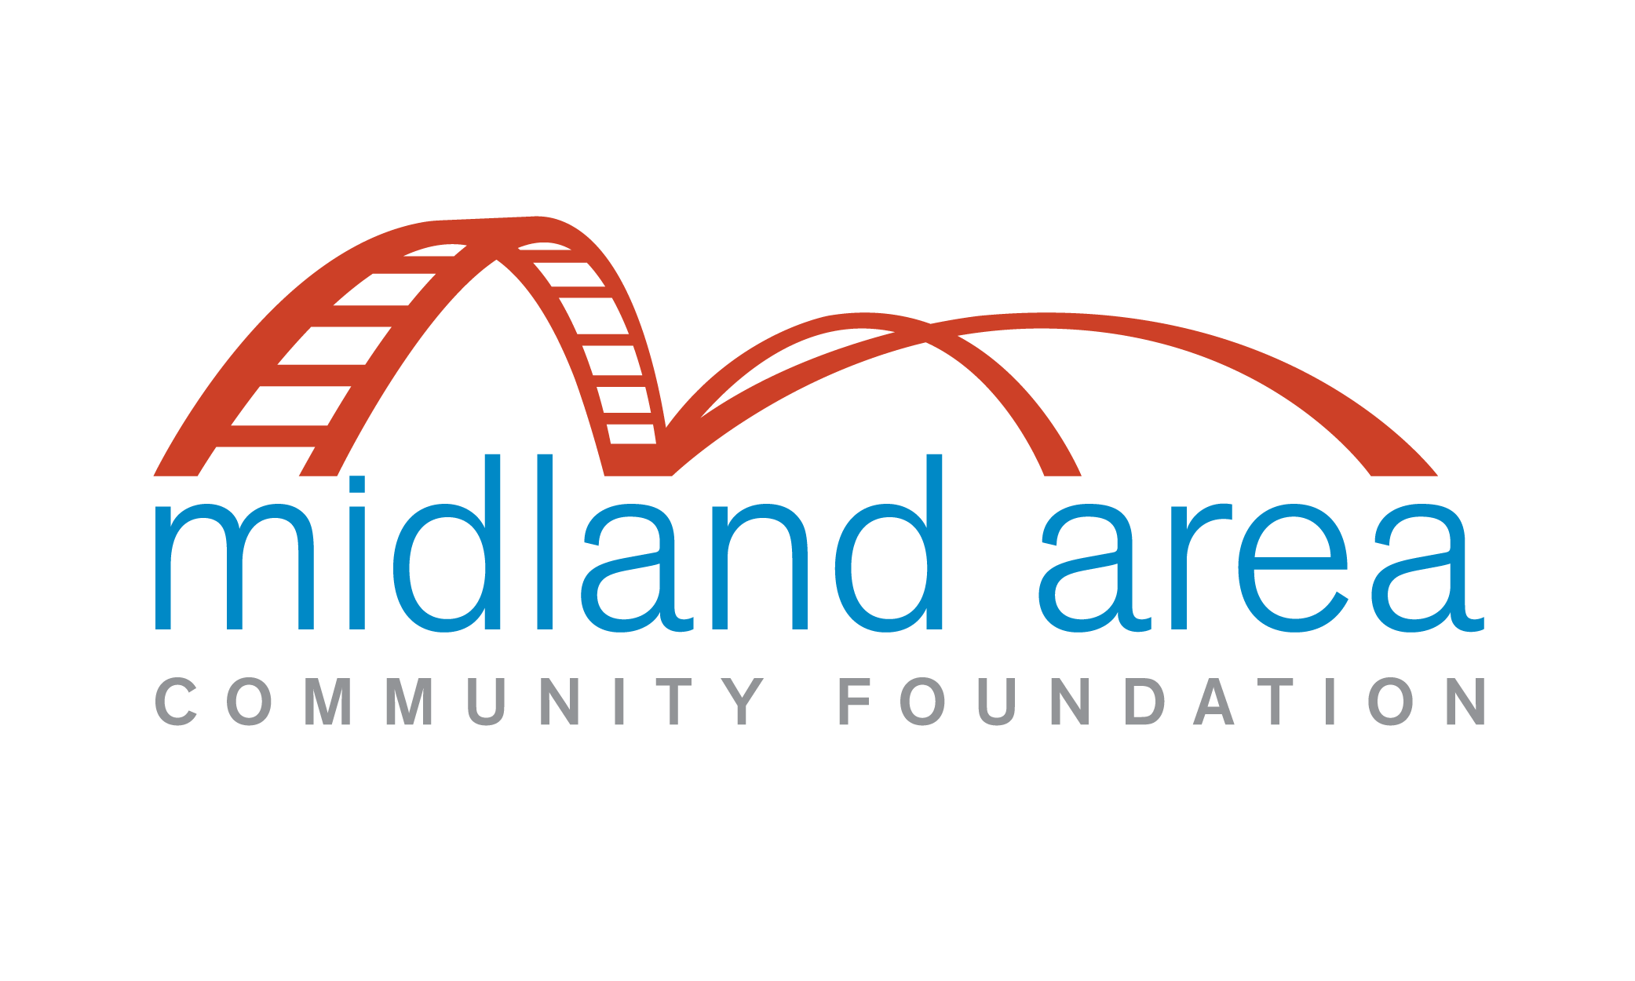

The Lloyd Osborn Memorial Award Rules

- The purpose of the Lloyd Osborn Memorial Award is to memorialize the qualities of dedication and service to sports and community exemplified by its namesake.
- The award will be conferred each year upon that person who in the view of the jury best combines service to sports and community. Any person who has engaged in the coaching or teaching of sports or has been in a leadership position in organized sports activities in Midland County will be eligible.
- Nominations for the award may be made by any resident of the county by submitting a written nominating statement to the Midland Area Community Foundation.
- Nominating statements should state briefly the nominee’s name and record of service, and indicate the benefits of this service to the community.
- Nominations will be accepted by the Foundation during the first calendar quarter of each year and the winner will be announced during the month of May.
- The award to the winner will consist of a cash prize of $1,000 to be awarded to a charity or charities selected by the winner and a suitably inscribed trophy. The winner’s name will be inscribed on a permanent plaque to be displayed at Northeast (Intermediate) Middle School in Midland.
- A jury appointed by the Midland Area Community Foundation will have full jurisdiction over selection of the winner. The jury will consist of five persons, two representing organized Midland area sports activities and two representing local community service organizations. The fifth person, representing the Foundation, will be the chairperson and be responsible for convening the jury and for the administrative details related to the award.
- The jury will invite nominations for the award by appropriate public announcement, consider the nominations received and decide the winner. Alternatively, the jury may select a person not formally nominated for the award, or may declare no winner.
- In no event, however, will a member, officer, or employee of the Midland Area Community Foundation, or any person in his or her immediate family, or a member of the jury, or any member of his or her immediate family, be eligible to receive the award.
- The rules of this award will be governed by the trustees of the Midland Area Community Foundation, who may amend them as they see fit.

